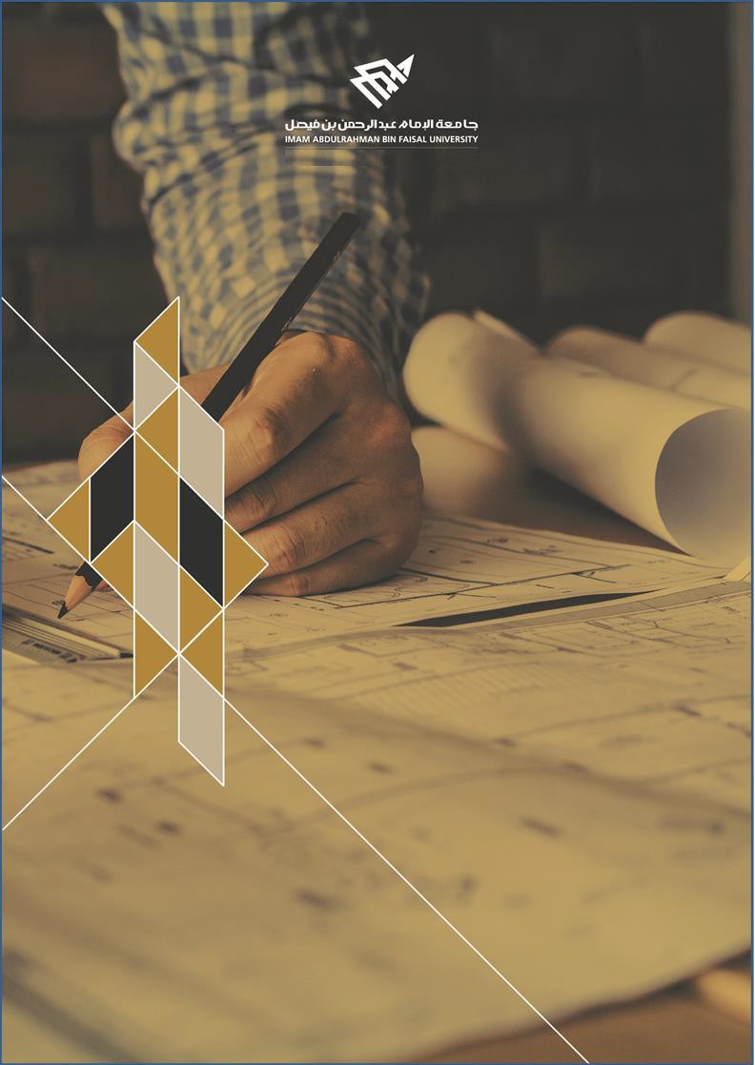

College of Computer Science and Information Technology
تامولعملا ةينقتو بساحلا مولع ةيلك

DEPARTMENT OF COMPUTER ENGINEERING

ARTI404 – Image Processing

STUDENT PROCEDURAL MANUAL Lab 1

2024 - 2025

College | Department | Course
College of Computer Science and Information Technology | Department of  Computer Science | ARTI407 – Image  Processing

Practical Session Plan

Session Topic/Title | Session No. | Session Duration  (Minutes)
Basics of programming with Python | 1 | 100

1- Session
Outcomes

Outcome#1: Explain how digital images are represented and manipulated in a computer.

2- Tool(s)/Software .
• Python 3
• Anaconda
• IDE for Python: Jupyter, Spyder.

3- procedural steps
(Tasks)

Step#1:Install Anaconda:

Download and install latest version of Anaconda from https://www.anaconda.com/
The current version of Anaconda is 3. After installation and running Anaconda, you will get similar environment, where Jupyter and Spyder are already installed, which are the target tools for this course.

Step#2: Start Jupyter or Spyder for Python.

You can start Jupyter or Spyder either from the Anaconda GUI (which is most time-consuming task. You can also start Jupyter or Spyder directly from the start menu (without starting Anaconda).

Step#3: Install Libraries / Packages in Python:

Most of the time you will need libraries/Packages in Python during your work. You will need the following libraries: SkyPi, OpenCV, scikit-image, Pillow, Matplotlib.

College | Department | Course
College of Computer Science and Information Technology | Department of  Computer Science | ARTI407 – Image  Processing

Step#4: Install NumPy:
Practical Session Plan

Google for NumPy, you will find some link, one of them will be NumPy.py (https://pypi.org/project/numpy/) copy and paste it in the command prompt of Jupyter and Spyder and it will be installed locally

Task#1: Exercise with Spyder:

Exercise the two cheat sheets for python practices in the resources section.

Task #2: Loading and Visualizing Images:

- Loading/reading image using OpenCv

import cv2
img = cv2.imread('images/cameraman.tif') #Load the image data into a NumPy array

import matplotlib.pyplot as plt
plt.imshow(img)
plt.show()

- Loading/reading image using PIL

from PIL import Image
img2 = Image.open('images/lena_gray_256.tif') #load image into a PIL Image object

import matplotlib.pyplot as plt
import matplotlib.cm as cm
plt.imshow(img2, cmap = cm.Greys_r)
plt.show()

Task #3: Image Storing
- Saving image to disc using OpenCV

cv2.imwrite('new_image.jpg', img)

- Saving image to disc using PIL

img2.save('new_image2.jpg')

Task #4: Display image as an Array

print(img.shape) #Note: img1 loaded using open cv is a numpy array
print(img)

import numpy as np
# Convert the image to a NumPy array
img_array = np.array(img2)

# Print the array
print(img_array.shape)
print(img_array)

4- Assessment

The student will be asked to perform different operations on the array using NumPy library.

5- Resources

NumPy cheat sheet

Python Basics cheat sheet

College | Department | Course
College of Computer Science  and Information Technology | Department of  Computer Science | ARTI407 - Image  Processing

Practical Session Plan
Appendix:

Course Code- Couse Na me 3I Page

